**Kilossery Equestrian Centre, Swords.**

**Sunday 28th April**

**Ciaran Glynn: Riders of ‘C’ standard**

**& upwards**

**Laura Glynn: Riders of below ‘C’ standard, who can jump 75/80cm**

**Spruce Lodge,**

**Redcross, Co. Wicklow**

**Tuesday 3rd April**

**With Heidi Hamilton**

**Riders must be jumping**

**75/80cm & upwards**

**Skull Caps & Back Protectors Compulsory**

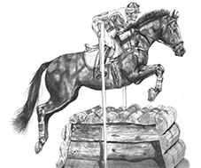

**Sessions will be Subsidised by Bray Pony Club**

**€35 per Bray PC Member**

**Times will be Confirmed to you by Text**

**Please enter using our online entries**